**Performed by:**

**Saurabh Jadhav : 192010045**

**Trupti Tekawade : 192011063**

**Shriram Bhagwatkar : 192010051**

**Experiment No .9** : Implementation: Final (End-to-End).

This is a personal photography company where people are able to see the art work of the photographers and can book the events we provide.

**Client Working**

**Home Page**

This is what a customer will see when he/she enter our website.

This is home page of our website.

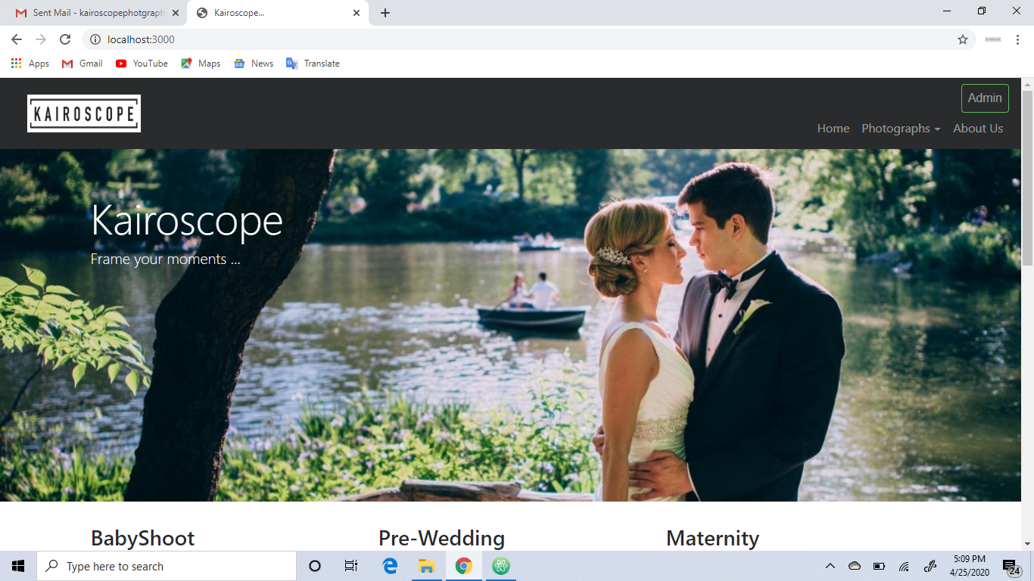

**Services :**

Here are some services we provide to our customer i.e shoot for pre-wedding ,Wedding , Engagement ,Maternity, Baby shoot.

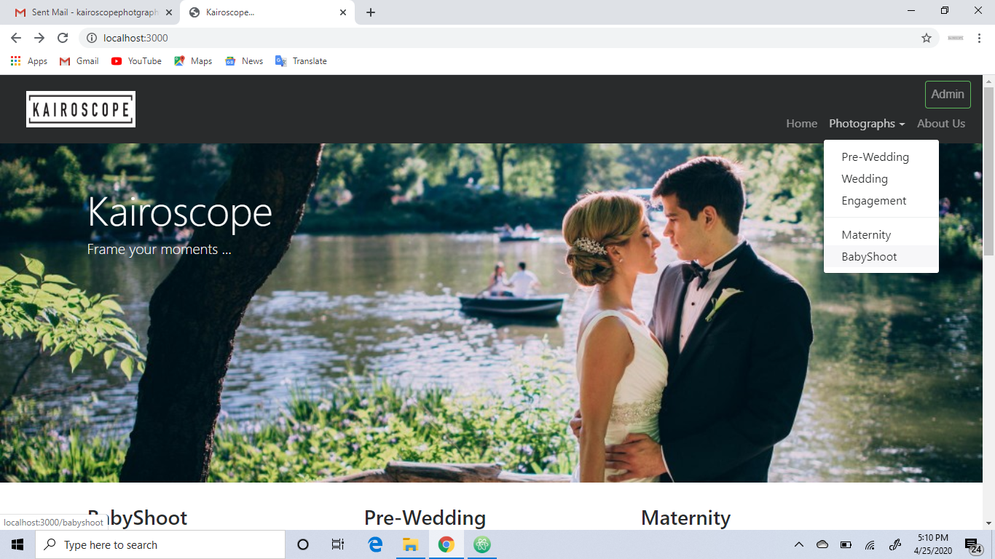

If a customer wants to book an event he/she just will take a view on our gallery and decide whether to place an order or not.

After deciding the event category the user will place order by filling his/her personal & event details.

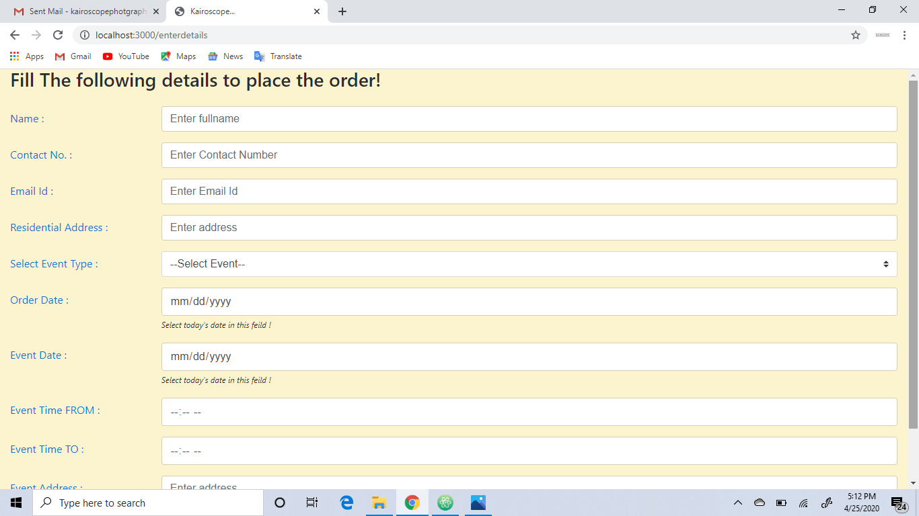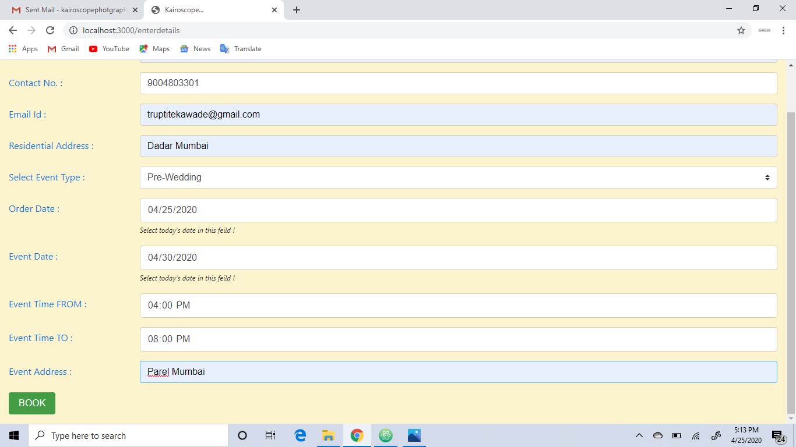

Like you can see at the below picture that the customer then click to the book photographer button.

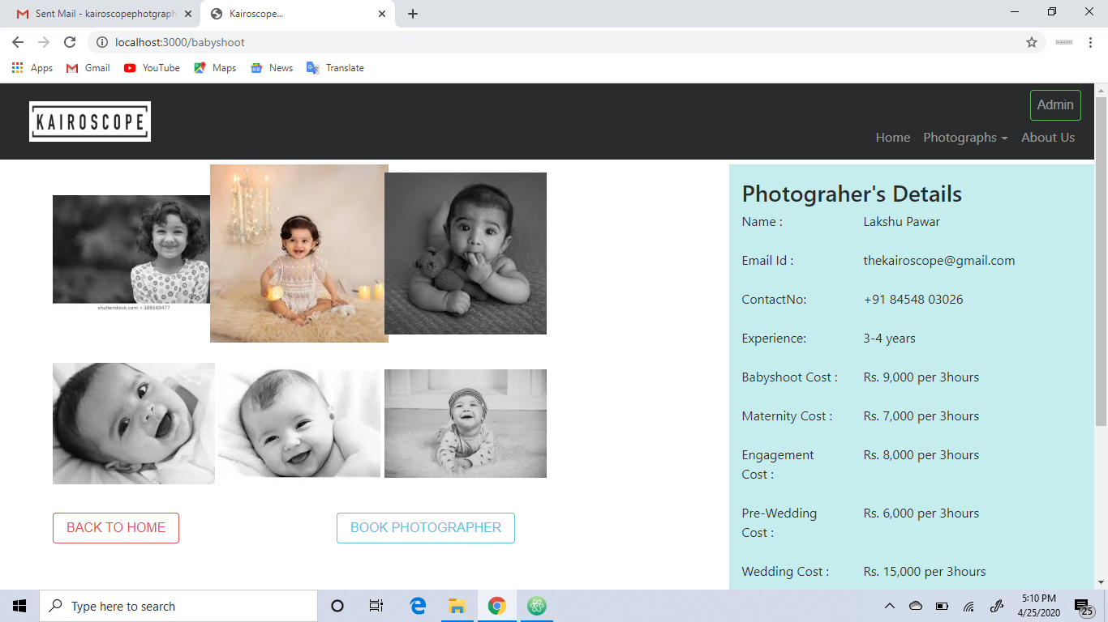

Confirm Order Page

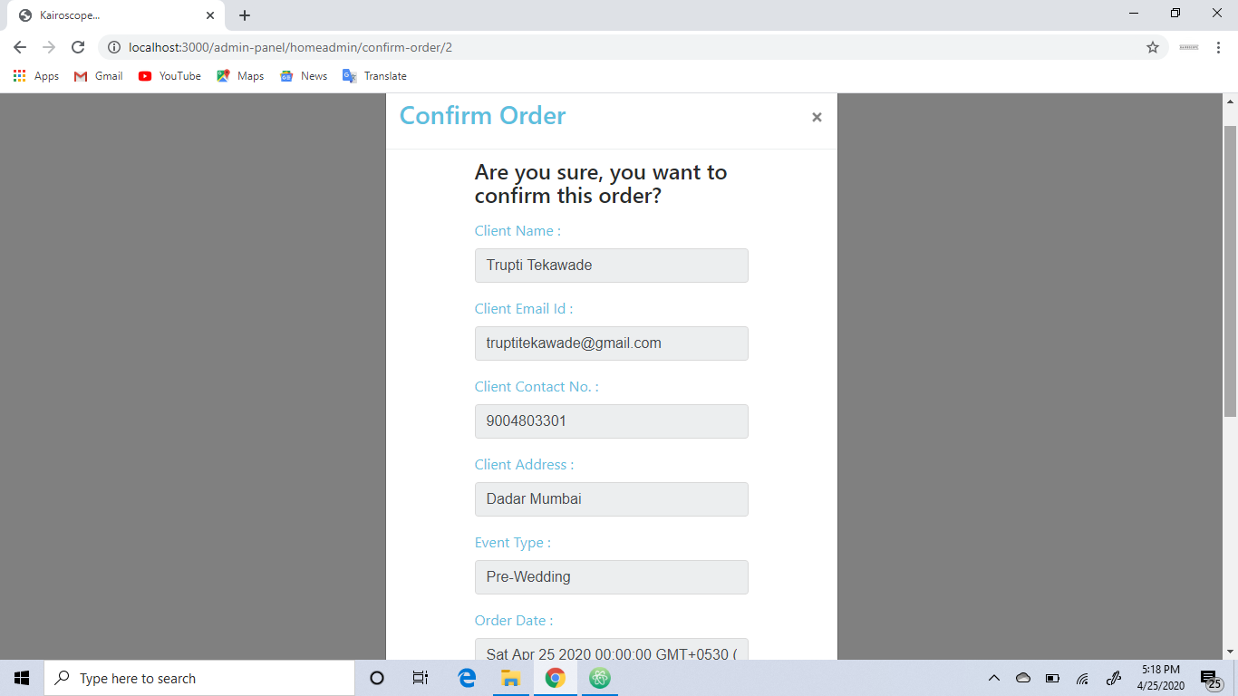

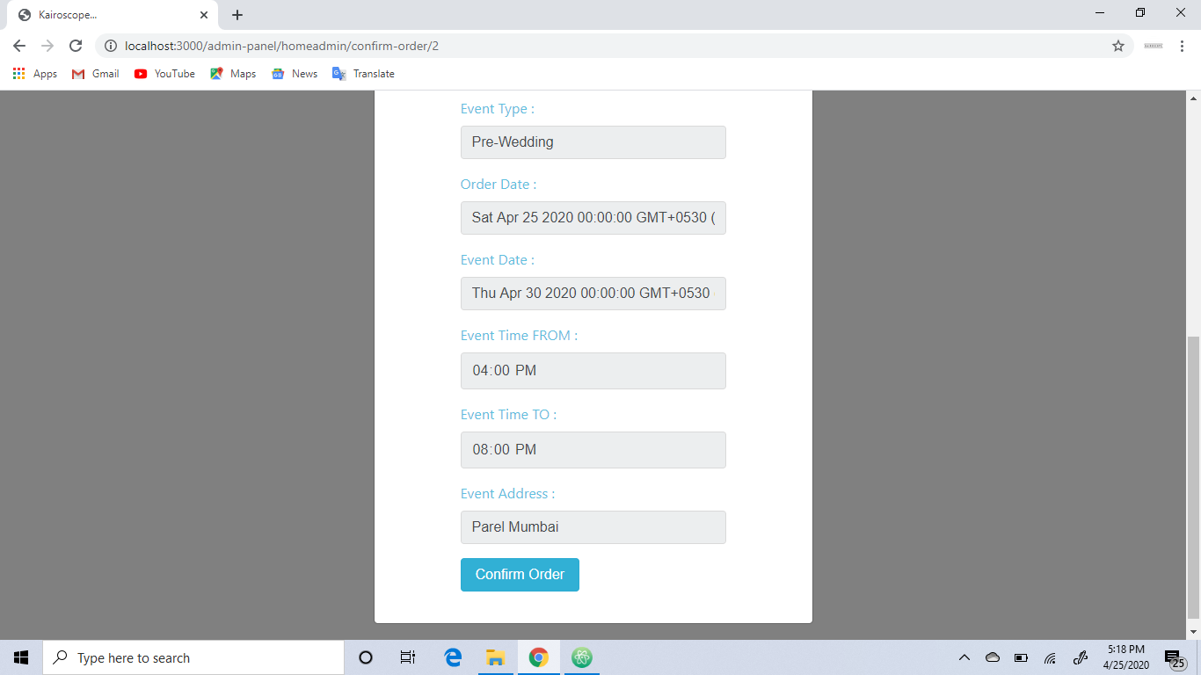

After confirmation you will get a successfully placed pop up.

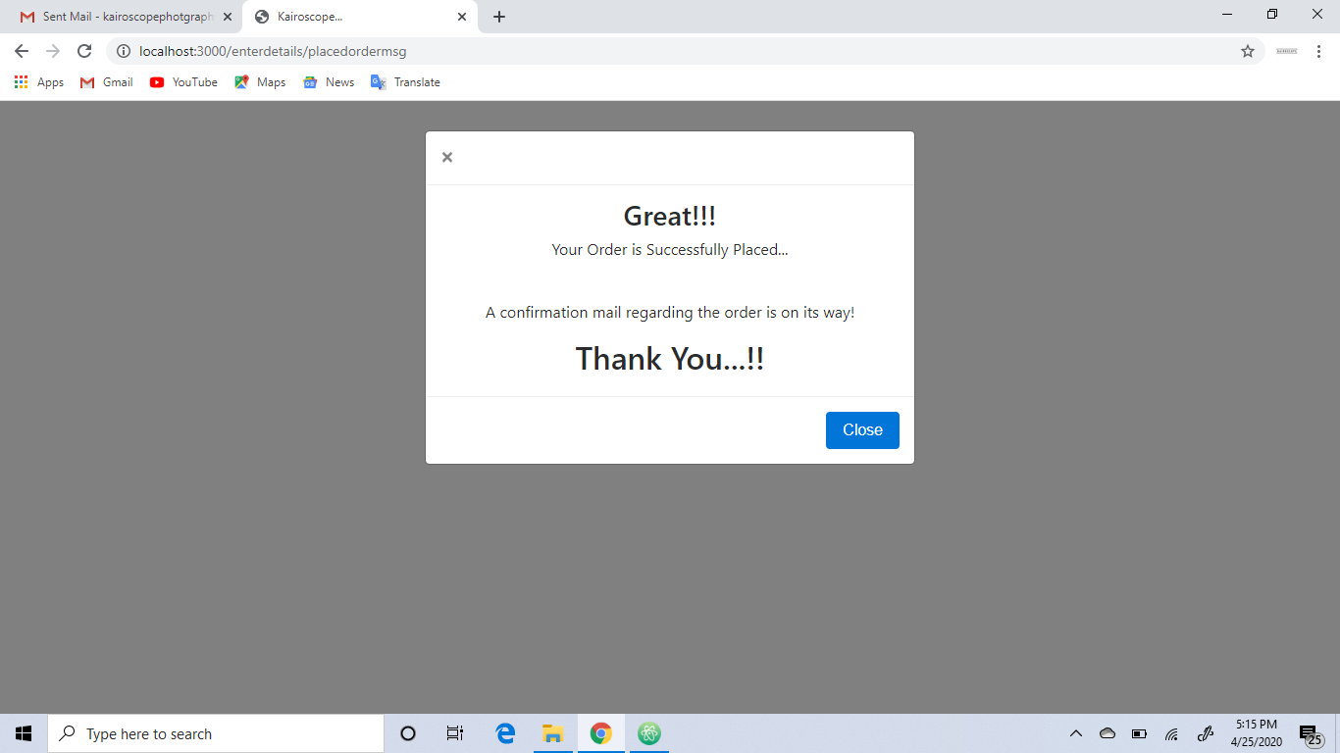

You also get a mail which notifies that you booked an event with us.

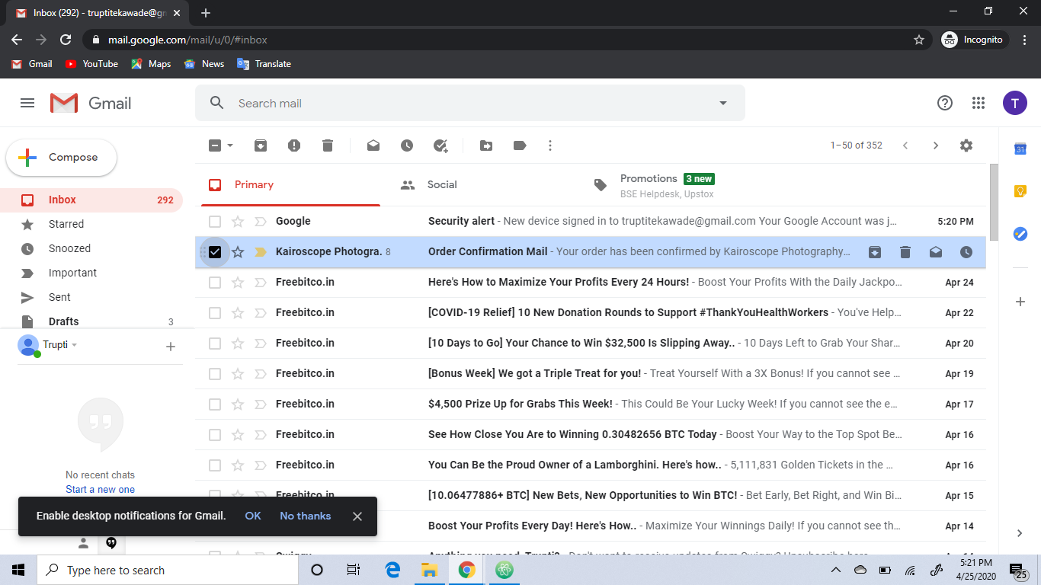

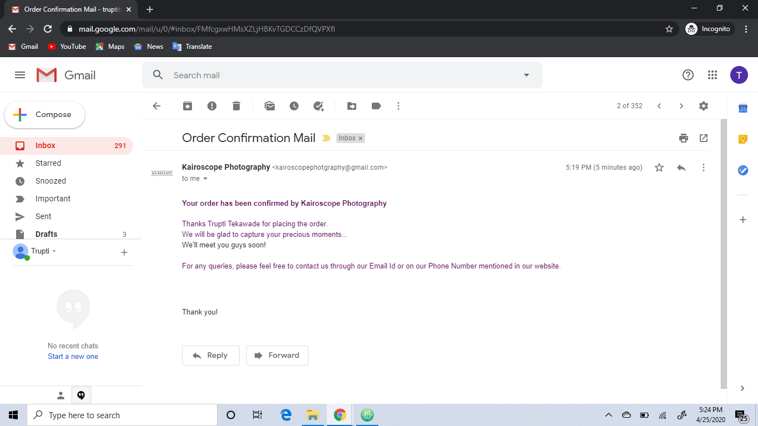

Admin Working

Admin will basically edit the cost of the event, check the pending orders, decide whether to accept the order according to the time availability and can also decline the order if we are already booked at that particular day

Admin Page

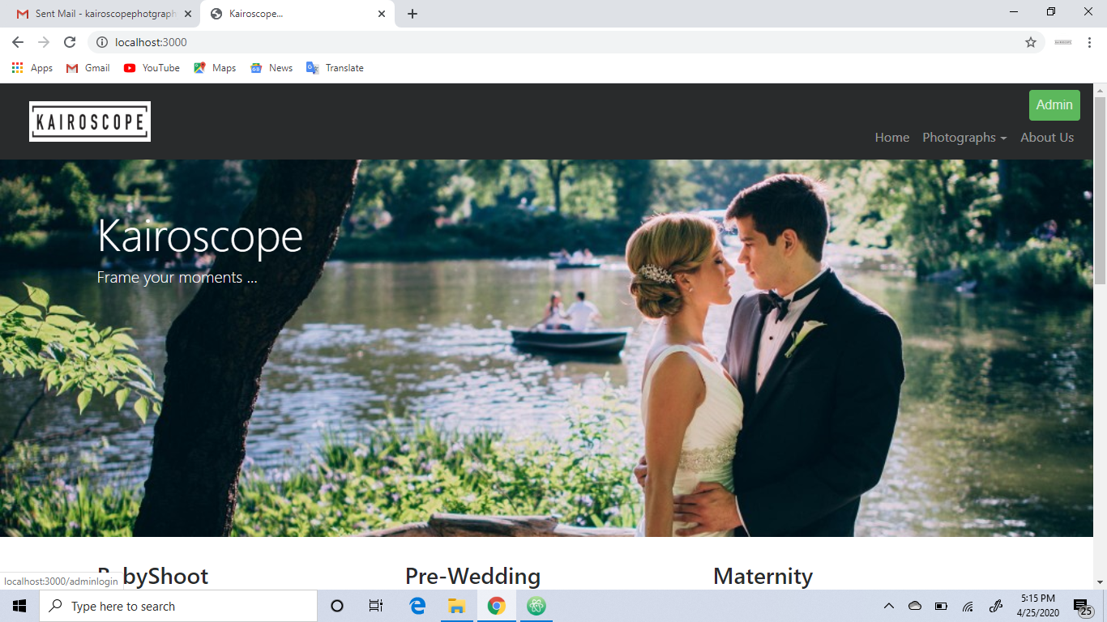

Admin Login Page

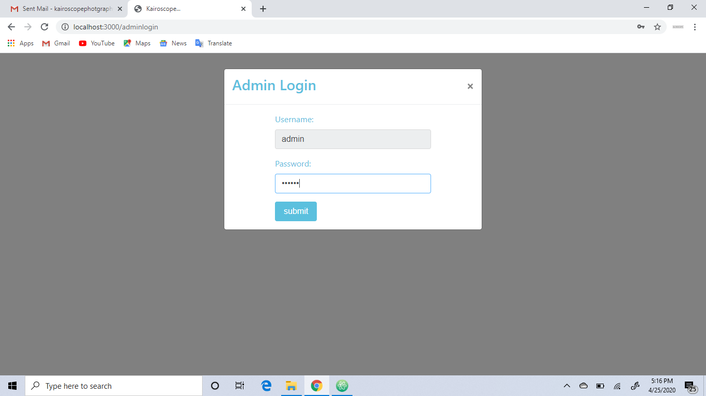

Edit Cost Page

Here the fee for pre-wedding event is Rs.6000.If admin want to change the cost he can change by clicking on the edit button.

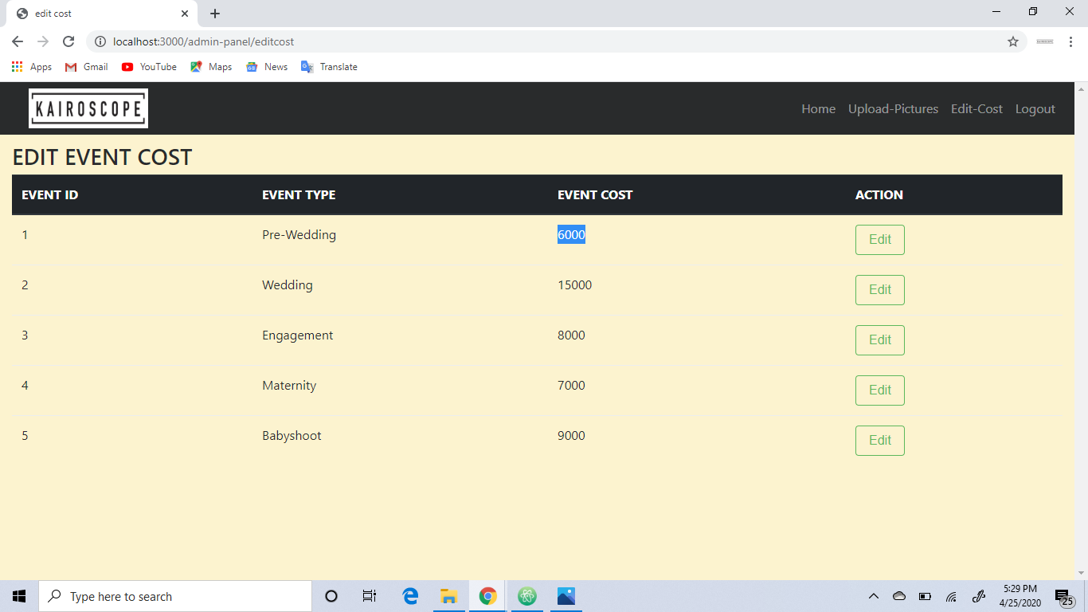

Here admin can enter the required updated amount and save the changes.

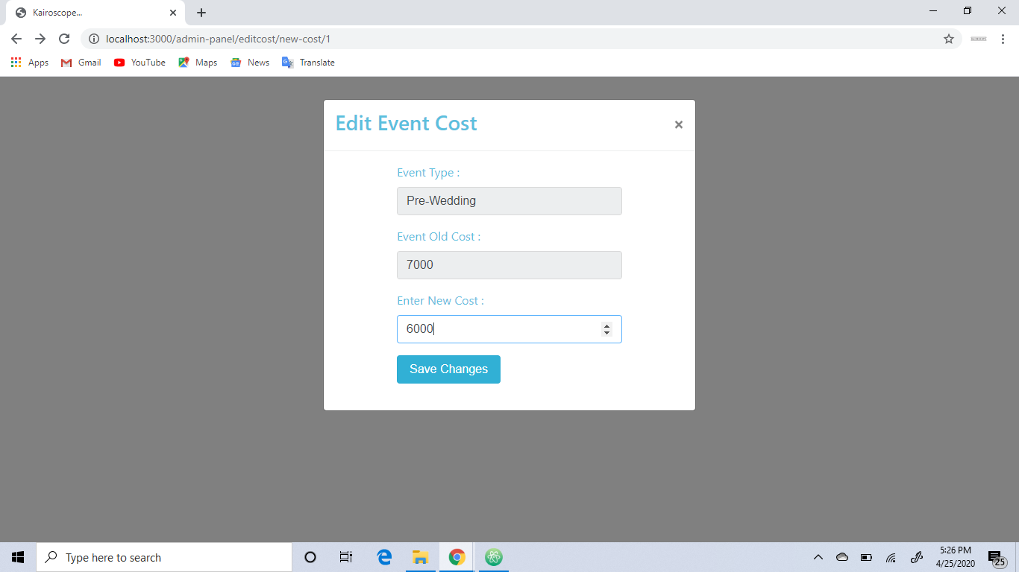

Previously the amount was Rs.6000 and after updation it became Rs.7000.

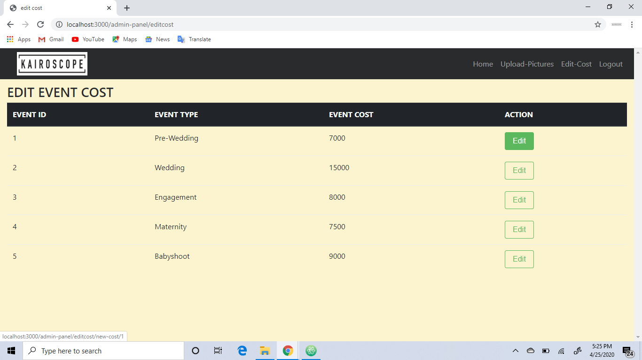

Pending Order Page

Here admin can check his/her pending orders and can confirm oor decline the orders.

